SET UP

1. Install Visual Studio

Install Visual Studio by following link: https://visualstudio.microsoft.com/vs/

3. IronPython

Install IronPython 3.4 by following link: <https://ironpython.net/>

Run and install IronPython.

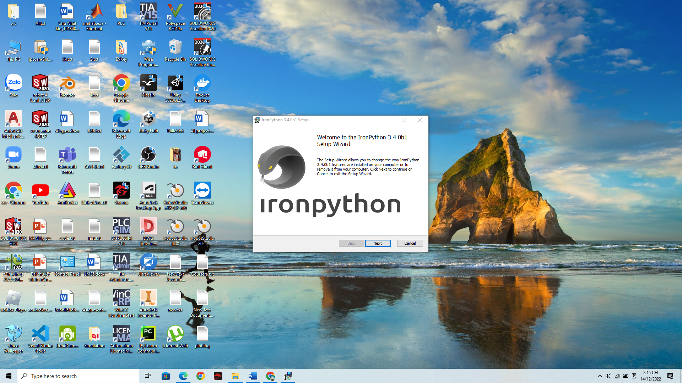

Note: You must put file IronPython in dir: C:\Program Files\

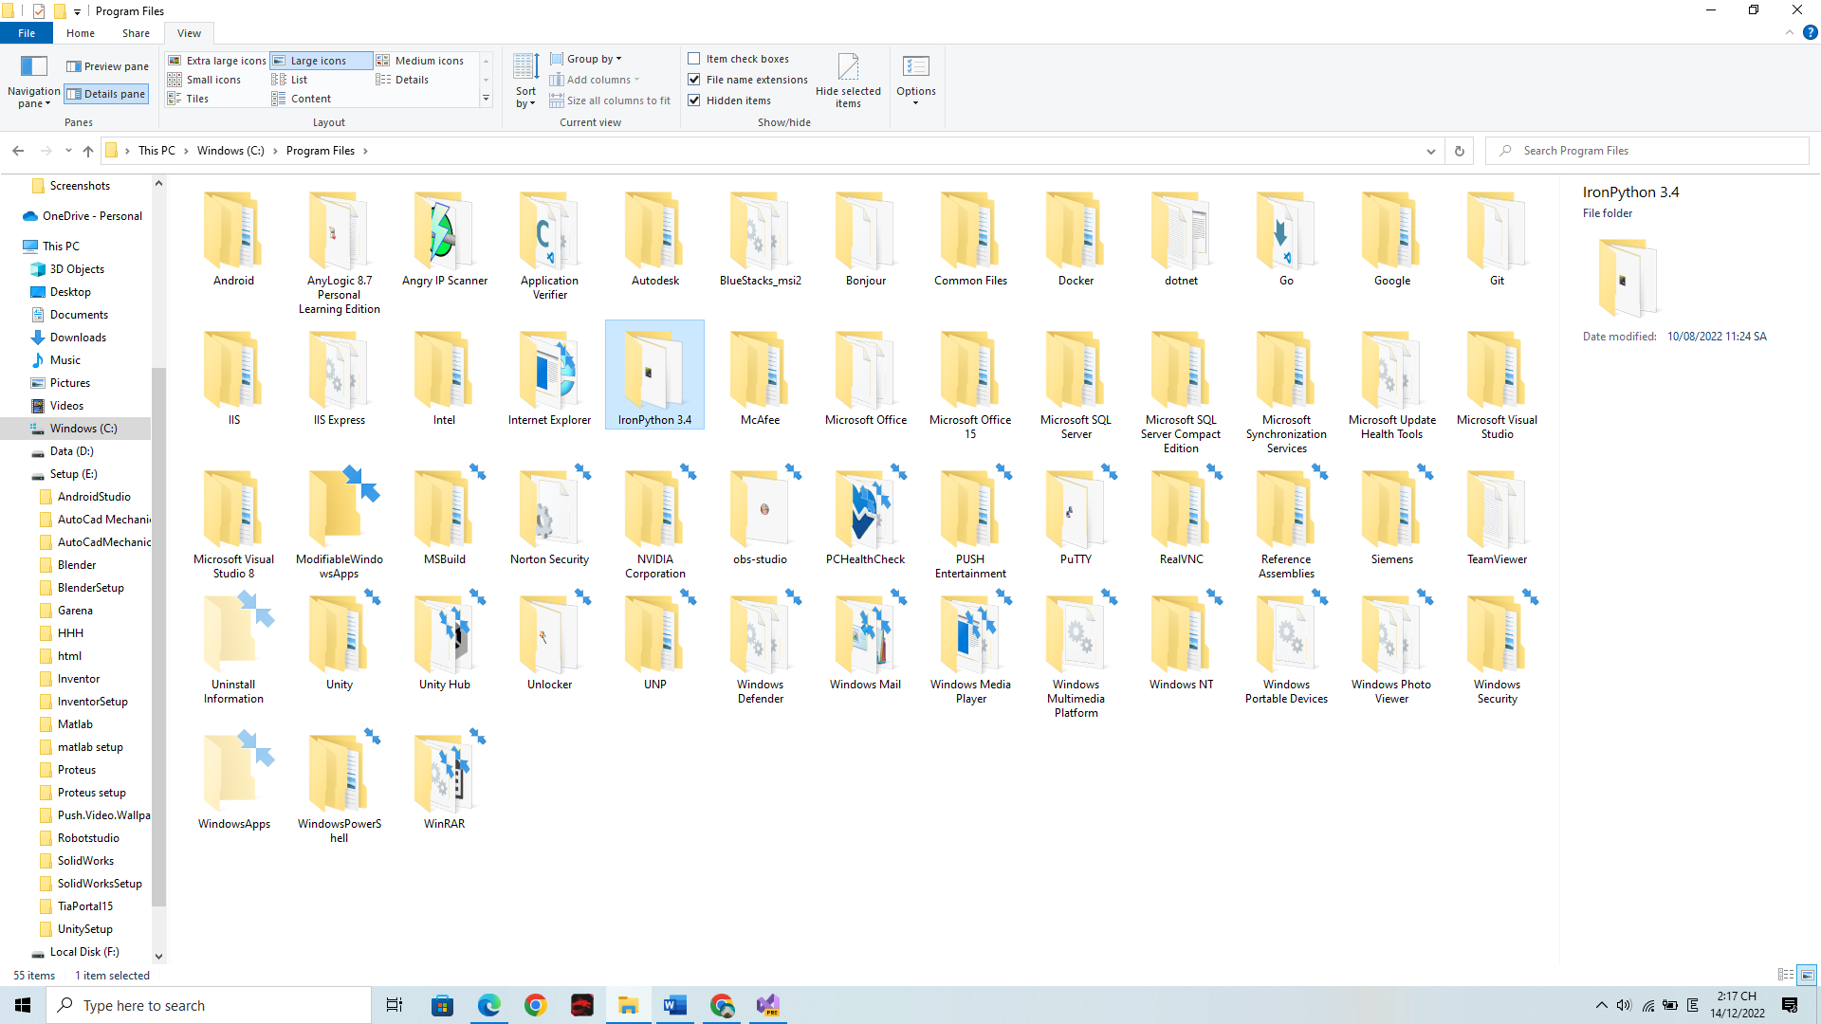

Add library for C# Project:

1. Open Project.

2. Go to Solution Explorer:

* Right Click at Reference and choose Add Reference

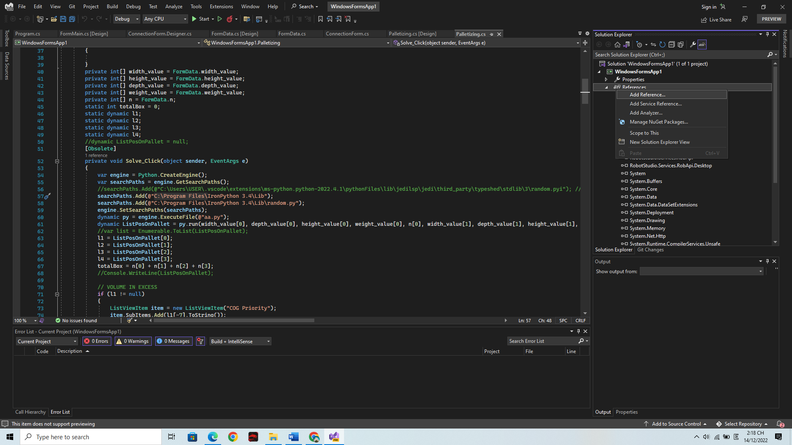

3. Choose all the library in IronPython file:

Click Browse and Go to file IronPython that you install in previous step.

Choose all file (.dll):

* IKVM.Reflection.dll
* IronPython.dll
* IronPython.Modules.dll
* Microsoft.Dynamic.dll
* Microsoft.Scripting.dll
* System.Buffers.dll
* System.Memory.dll
* System.Runtime.CompilerServices.Unsafe.dll

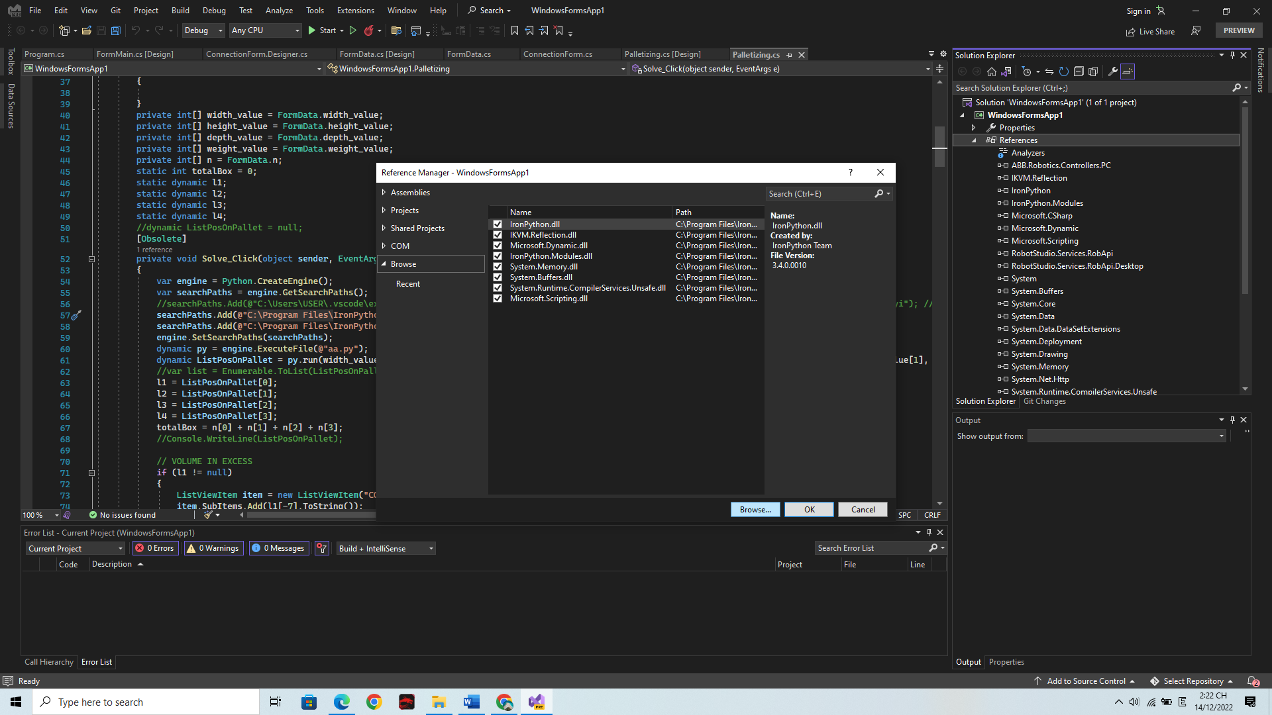Click Ok